Enter his gates with thanksgiving,

and his courts with praise!

Date:_______________________________

Name:­­_____________________________

Color on the Altar:___________________

Anything different/special?

(communion, baptism font, banners, advent wreath)

___________________________________________

Pray About What You See

* Cross – thank Jesus for dying for our sins
* Pastor – ask God to give him love and wisdom
* Musicians – thank God for the musical gifts they share
* People – pray for the people who are worshiping next to you
* What else do you see? Say a prayer!

Prepare for worship!

What I learned from

the sermon and readings:

Sermon Title/Text:________________________

___________________________________________Message Notes:______________________________ ________________________________________________________________________________________________________________________________________________________________________________________________________________________________________________________________________________________________________________________________________________________________________________________________________________________________________________________________________________________________________________________________________________________________________________________________________________________________

Check your worship card for the sermon title!

**Words I Hear:**

* Jesus
* Forgiveness
* Baptism
* Amen
* Grace
* Faith
* Hallelujah
* Pray
* Holy Spirit
* Believe
* God
* Sin
* Salvation

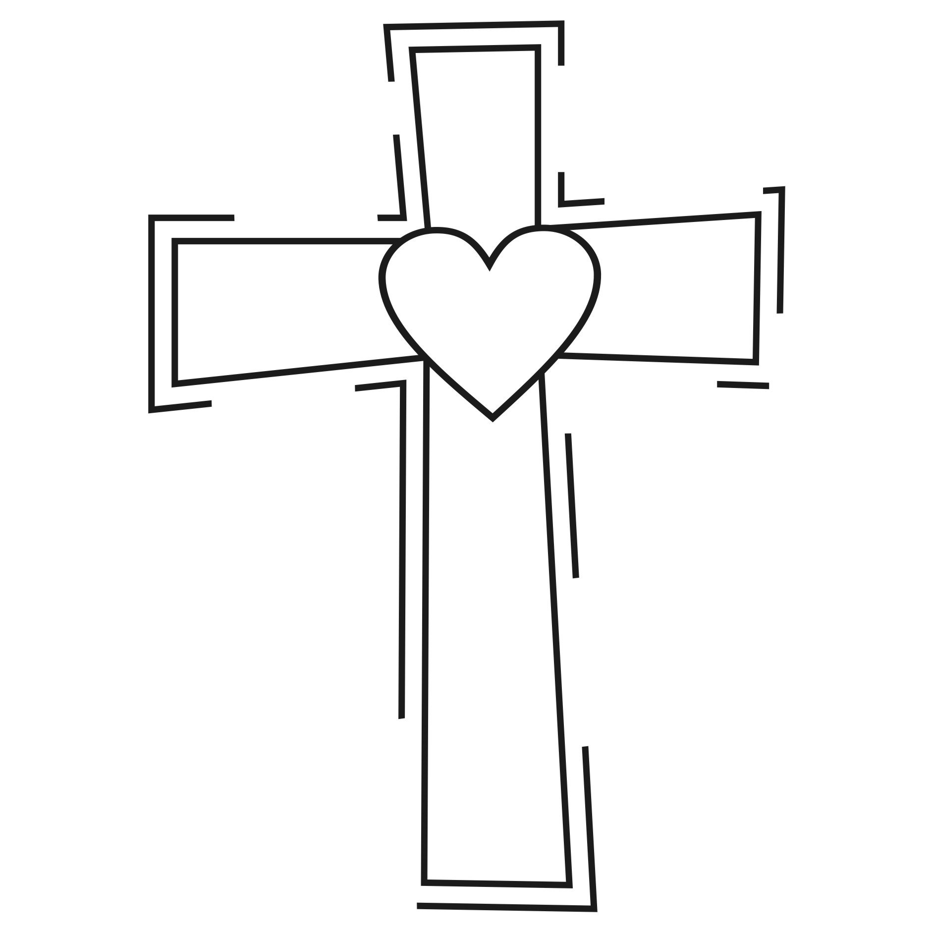



For by grace you have been saved through faith. And this is not your own doing; it is the gift of God.

Ephesians 2:8

My Prayers this Week:

________________________________________________________________________________________________________________________________________________________________________________________________________________________________________________________________________________________________________________________________________________________________

Listen carefully to pastor’s prayers in church for ideas!

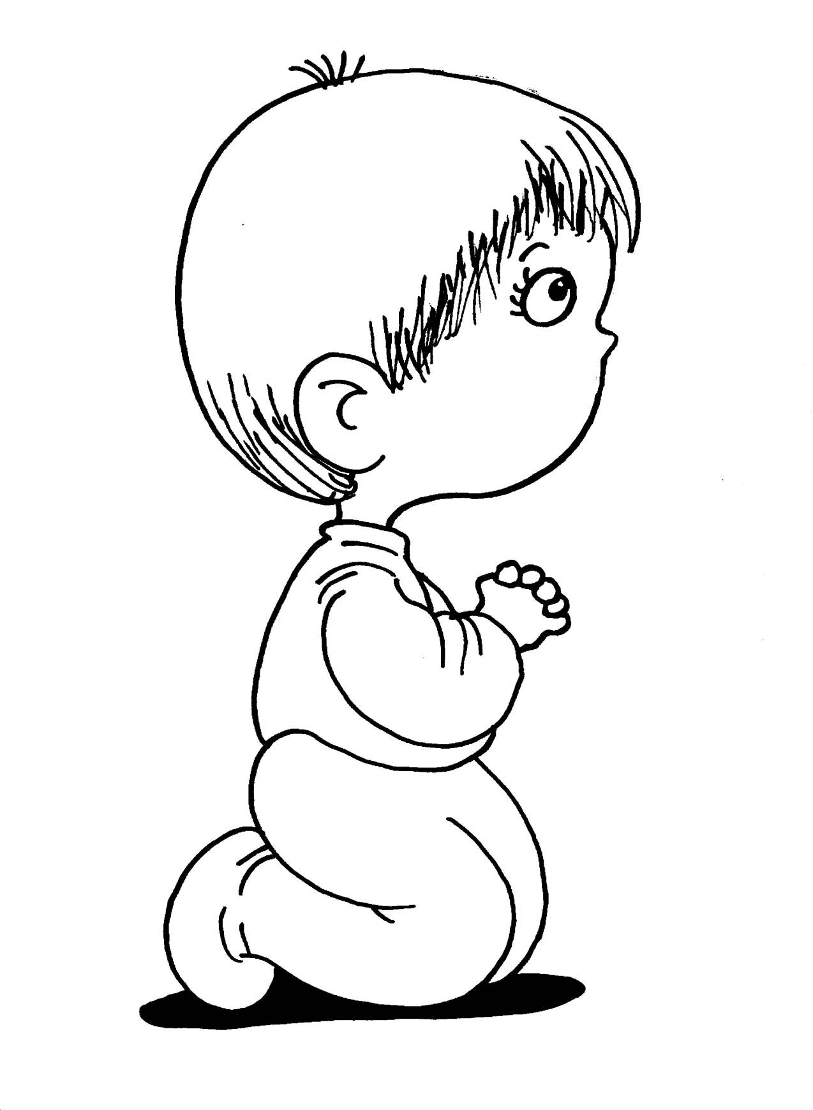

My Favorite Song Today

__________________________________

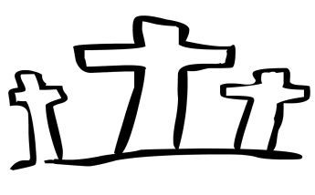

For doodles or thoughts!

For doodles, picture or other thoughts!

Weekly Memory Verse

______________________________________________________________________________________________________________________________________________________________________________________________________________________________________________________________________________

________________________ ______ : ______

Use the verse from Sunday School or choose one from the readings. Ask an adult to learn it with you!

Questions

I have from the service today!

The Lord bless you and keep you. The Lord make His face shine on you and be gracious to you.

The Lord look upon you with favor and give you peace.

Numbers 6:24-26

___________________________________________________________________________________________________________________________________________________________________________________________________________________________________________________________________________________________________________________________________________________________________________________________________________