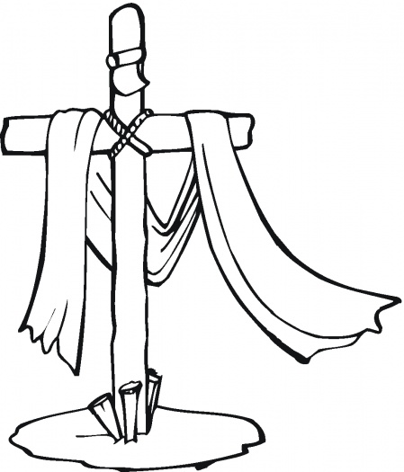
Good Friday

Tenebrae Service
Children’s Service Bulletin

Color along with the service!

After each reading, Pastor will extinguish one candle.

Color over each candle with a black crayon as each candle is put out.

Once all the candles are extinguished, the seventh candle will be removed from the sanctuary.

After a loud noise, which reminds us of Christ’s tomb being sealed, the seventh candle is returned, showing Christian hope in the resurrection of our Lord.
Reading 1: Luke 23:32-38
THE WORD OF FORGIVENESS
Two others, who were criminals, were led away to be put to death with him. And when they came to the place that is called The Skull, there they crucified him, and the criminals, one on his right and one on his left. And Jesus said, “Father, forgive them, for they know not what they do.” And they cast lots to divide his garments. And the people stood by, watching, but the rulers scoffed at him, saying, “He saved others; let him save himself, if he is the Christ of God, his Chosen One!” The soldiers also mocked him, coming up and offering him sour wine and saying, “If you are the King of the Jews, save yourself!” There was also an inscription over him, “This is the King of the Jews.”
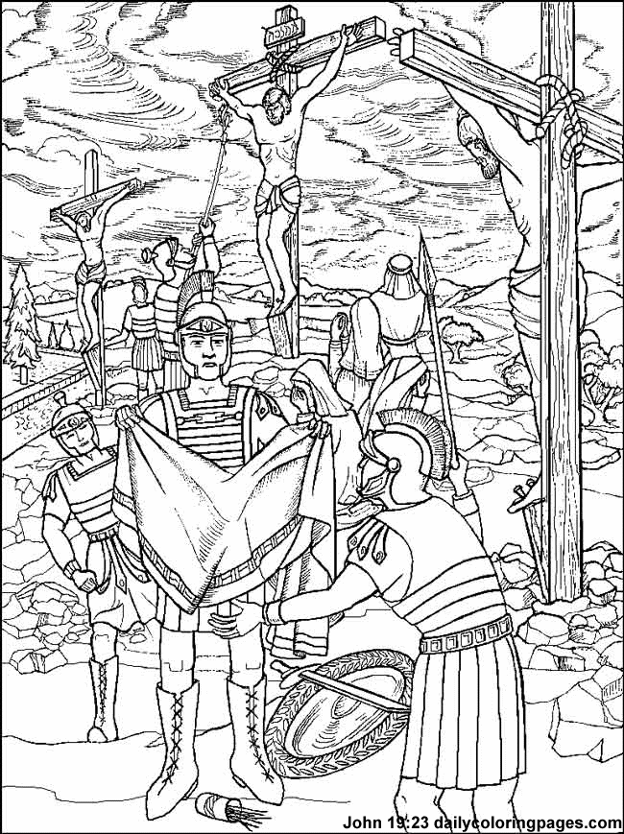

Reading 2: Luke 23:39-43
THE WORD OF SALVATION
One of the criminals who were hanged railed at him, saying, “Are you not the Christ? Save yourself and us!” But the other rebuked him, saying, “Do you not fear God, since you are under the same sentence of condemnation? And we indeed justly, for we are receiving the due reward of our deeds; but this man has done nothing wrong.” And he said, “Jesus, remember me when you come into your kingdom.” And he said to him, “Truly, I say to you, today you will be with me in paradise.”
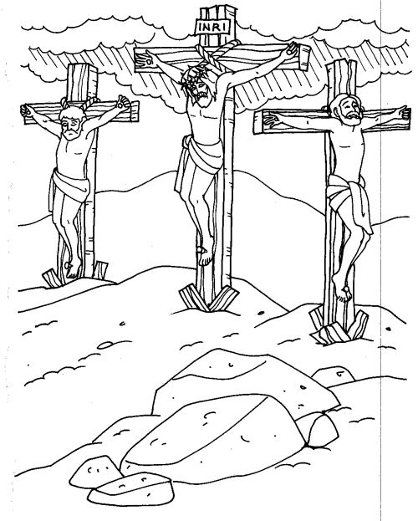

Reading 3: John 19:25-27
THE WORD OF LOVE
But standing by the cross of Jesus were his mother and his mother's sister, Mary the wife of Clopas, and Mary Magdalene. When Jesus saw his mother and the disciple whom he loved standing nearby, he said to his mother, “Woman, behold, your son!” Then he said to the disciple, “Behold, your mother!” And from that hour the disciple took her to his own home.

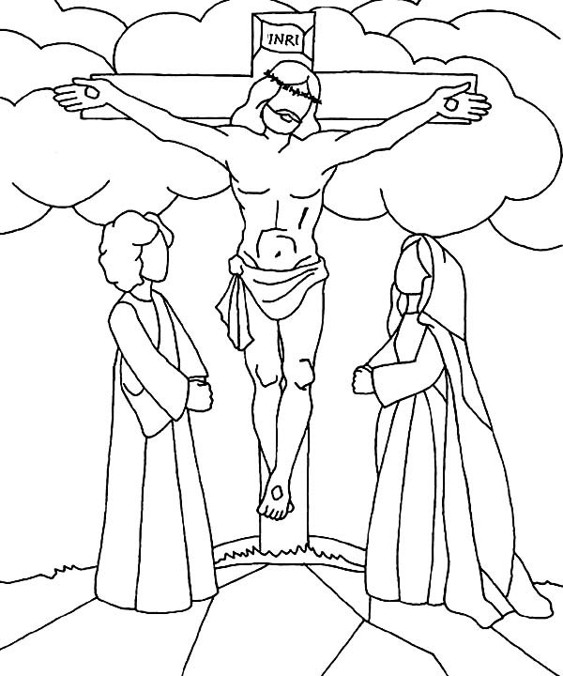
Reading 4: Mark 15:33-34
THE WORD OF FORSAKENESS
And when the sixth hour had come, there was darkness over the whole land until the ninth hour. And at the ninth hour Jesus cried with a loud voice, “Eloi, Eloi, lema sabachthani?” which means, “My God, my God, why have you forsaken me?”

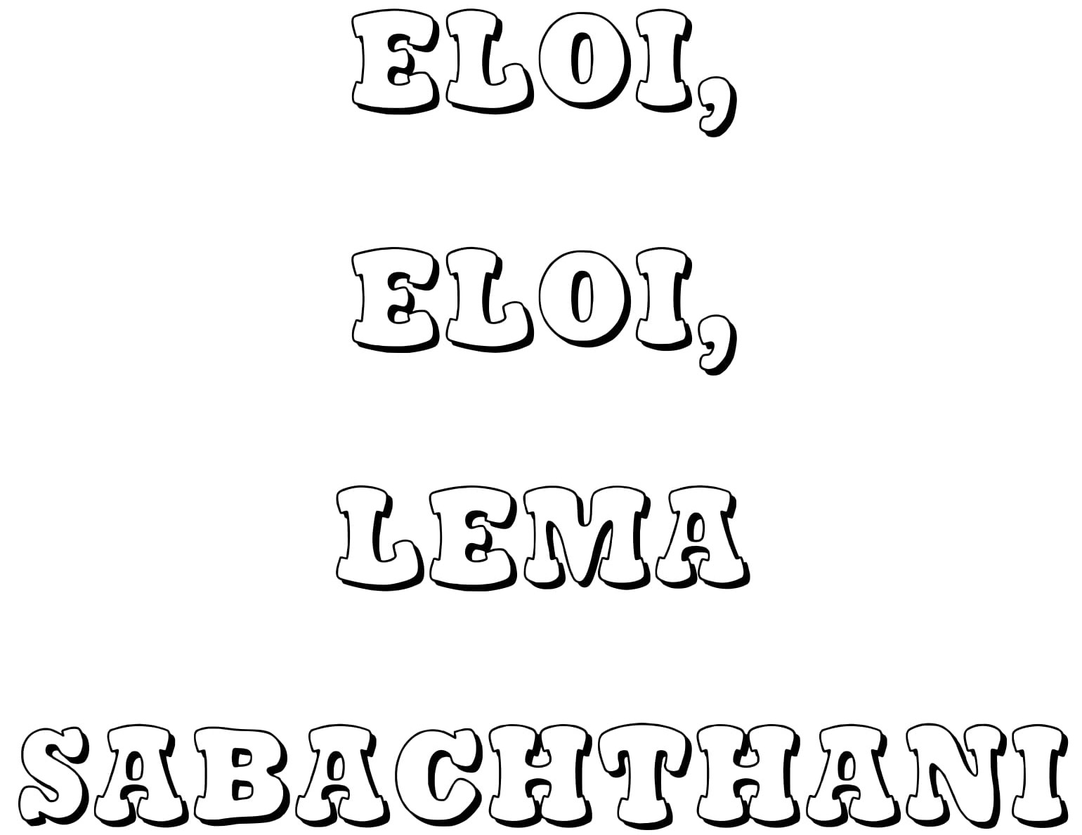
Reading 5: John 19:28-29
THE WORD OF THIRST
After this, Jesus, knowing that all was now finished, said (to fulfill the Scripture), “I thirst.” A jar full of sour wine stood there, so they put a sponge full of the sour wine on a hyssop branch and held it to his mouth.

Reading 6: John 19:30
THE WORD OF TRIUMPH
When Jesus had received the sour wine, he said, “It is finished,” and he bowed his head and gave up his spirit.
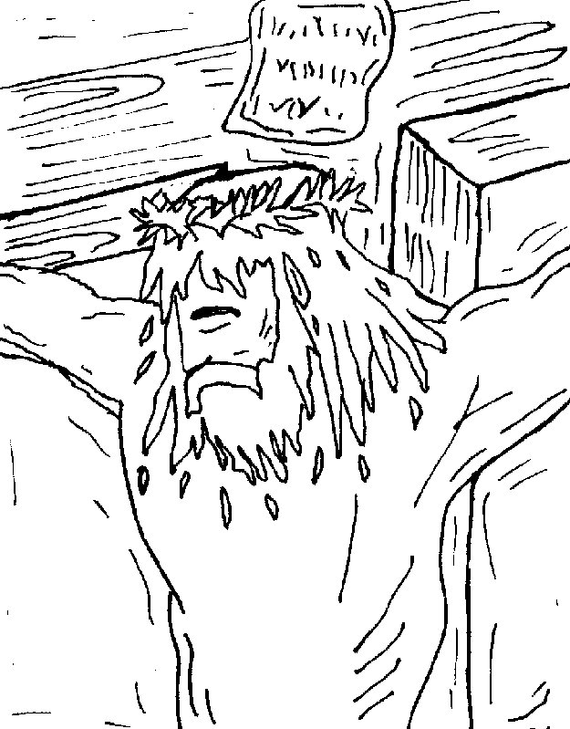

Thanks to Bill Lazasz for donating this coloring page to the public domain, Jan 2003, Christian Character Builders

Reading 7: Luke 23:44-49
THE WORD OF COMMITMENT
It was now about the sixth hour,^{[a]} and there was darkness over the whole land until the ninth hour, while the sun's light failed. And the curtain of the temple was torn in two. Then Jesus, calling out with a loud voice, said, “Father, into your hands I commit my spirit!” And having said this he breathed his last. Now when the centurion saw what had taken place, he praised God, saying, “Certainly this man was innocent!” And all the crowds that had assembled for this spectacle, when they saw what had taken place, returned home beating their breasts. And all his acquaintances and the women who had followed him from Galilee stood at a distance watching these things.
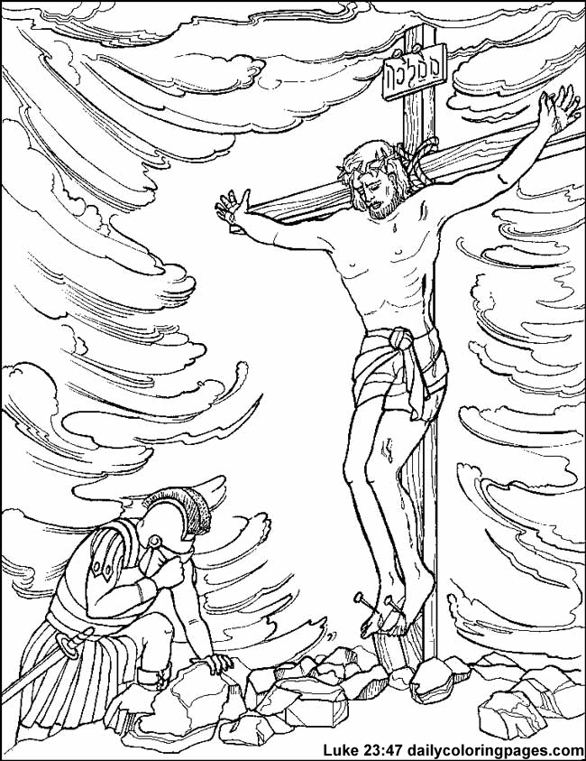

The

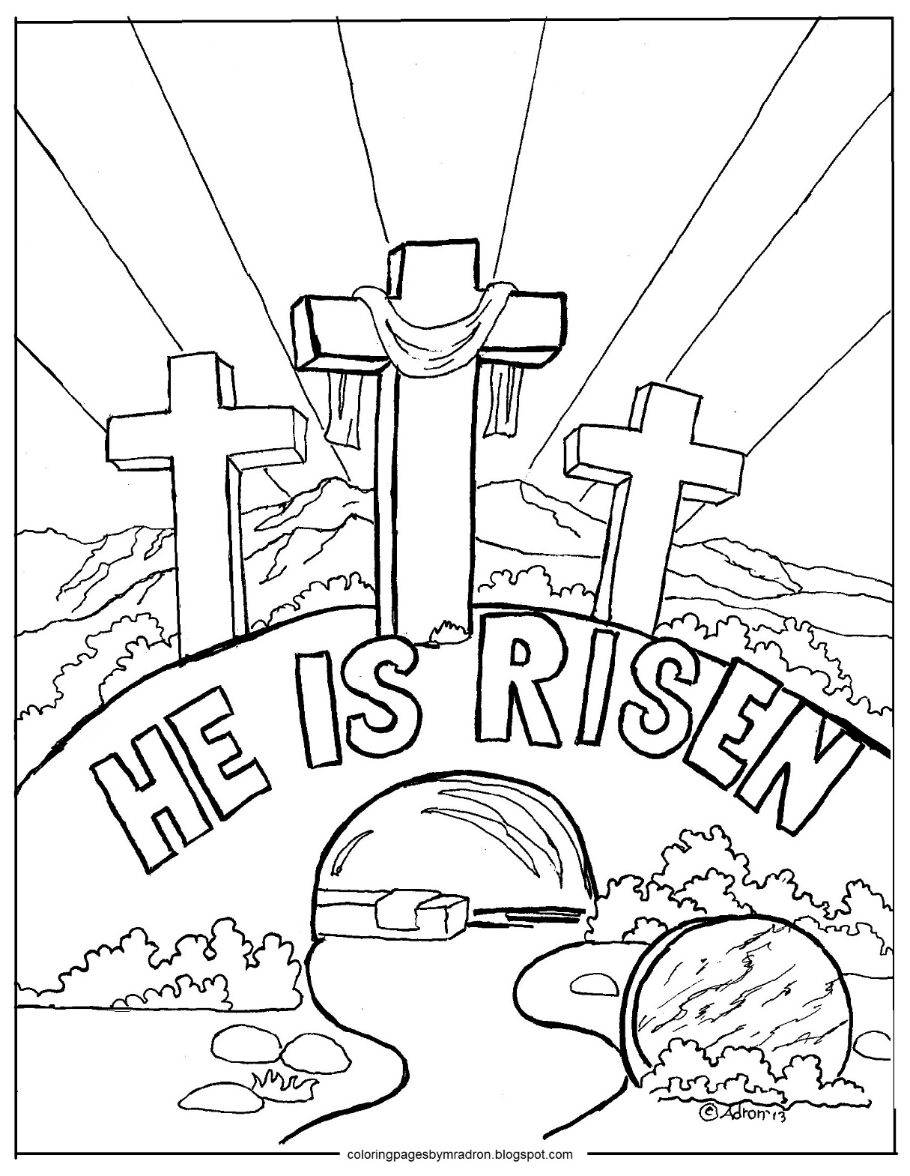

But that’s not the end! Remember Jesus didn’t stay dead. He rose on Easter morning. He’s alive!

Join us to celebrate Jesus’ resurrection at 7am or 10:30am on Easter Sunday!

